**4. Decart coordinates**

Create program which calculate the distance (D) between two points (A and B) in a plane, set with their coordinates

– A(Xa, Ya)

– B(Xb, Yb)

The formula for calculating the distance is:

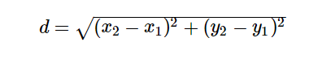

At the end you program should have similar results :

